**Angeles  City Science High School**

**Conchem 9**

Name:Paul Gerald D. Pare  Section:9 - Adenine

**ACTIVITY No. 4: Organ I I I I – I I**

Objective: Locate the affected organs upon over consumption of different food additives found on the different products

Direction: Use information below to look for the affected organs. Draw a line to indicate the affected orgran. One (1) line is equal to one (1) point.

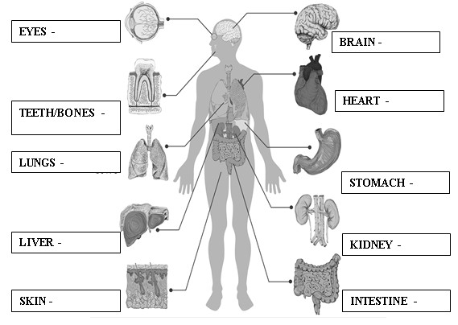

|  |  |
| --- | --- |
| **Food Additives Effects** | |
| Tartrazine (E102) FD&C Yellow No. 5 Quinoline yellow  (E104) | Asthma, rashes and hyperactivity. Potential carcinogen in animals: implicated in bladder and  liver cancer |
| Brilliant Blue (E133) | vomiting, skin rashes, and brain tumors. DNA  damage |
| Sulphur Dioxide (E220) | May induce gastric irritation, nausea, diarrhea, asthma attacks, skin rashes. Destroys vitamin B1. Causes fetal abnormalities and DNA damage in  animals |

|  |  |
| --- | --- |
| Saccharine (E954) | blood sugar levels and digestive function. Causes cancer of the bladder, uterus, ovaries, skin and blood vessels in animals. Linked to DNA damage  and congenital abnormalities in animals. |
| Sodium chloride, or  table salt | high blood pressure, cardiovascular diseases,  kidney diseases |
| Monosidium glutamate | high risk for diabetes, stroke, tumor, brain  injury, high blood pressure, meningitis and encephalitis |
| High Fructose Corn Syrup (HFCS) | Complications of diabetes Fatty liver Increased triglycerides Increased uric acid Chronic diarrhea  Irritable bowel syndrome Hives. |

|  |  |  |  |
| --- | --- | --- | --- |
| Eyes | 0 | Brain | lllll |
| Teeth/bones | 0 | Hearth lll | |
| Lungs | ll | Stomach llll | |
| Liver  Skin | llll  lll | Kidney l  Intestine l | |

Guide Questions

1. The might experience brain injuries such as stroke or behavioural changes.
2. Lessen the preserved food intake

Guide Questions

1. Which organ is the most affected?

Brain

2.a What will happen if the most affected organ was severely damage after too much consumption of food additives?

They might experience brain injuries such as stroke or behavioural changes.

2b. What would you do prevent this from happening?

Lessen the preserved food intake

**Activity No. 5: Space Puzzle**

Objective: Construct sentences about the positive effects of food preservation.

Direction: Analyze the following sentences written below. These sentences have INCORRECT SPACES. Rewrite these sentences with CORRECT SPACES on the lines provides below.

1. Save upon money:You won’tne edtobuy foodstuffse veryti mey oun eedsom e.Keepin gsome healthyfoodp reservationor doingthesamea thome canhelpyousaveups omenicebu ckseveryday.

2. Easya

omeofthefoodpreserve dbyyoua thomeorth eonesthat areavaila bleinthe market.Thisway,atthetimeofemergenc y,foodpreserv ationdoes helpsomeon efillth eirhunger

lternativeincaseofe mergency :Youcaneats

1. Save upon money. You won’t need to buy food stuffs every time you need some. Keeping some healthy food prevation or doing the same at home can help you save up some nice bucks everyday.
2. Easy alternative in case of emergency home: you can eat some of the food preserved by you at home or the ones that are available in the market. This way, at the time of emergency, food preservation does help someone fill their hunger.

Guide Question

1. How does food preservative help during the COVID-19 pandemic?

It helps us into keeping us safe and healthy while inside of our home instead of risking our lives outside buying some food that we can eat. Another thing is that, if the food sellers outside have the virus, then we aren’t really sure if we can get that disease.

**ACTIVITY No. 6: Dried and loss**

Objective/s

* 1. Describe the loss of nutrients and vitamins in food preservation - drying
  2. Construct the pie chart to summarize the loss of nutrients and vitamins in food preservations

Direction:

1. Study the table.
2. Show the **percentage of** loss of nutrients and vitamins in drying
3. **Color and Label** your pie chart.



80

50

10

0

10

0

0

0

10

Zinc

copper

Calcium

Phosphorus

Vitamin B6

Niacin

Vitamin B12

Vitamin C

Folic Acid

50

Vitamin A

**Maximum Nutrient losses (%)**

**Vitamins/ Minerals**

**Maximum Nutrient losses (%)**

100

50

0

Vita… Vita… Folic… niacin

Vita… Vita… Calci… Iron Pho… zinc cop…

Guide Questions

1. How does the nutrients of fresh mangoes compared to salted dried mangoes? Why?

Fresh mangoes have more nutrients and vitamins compared to dried mangoes since it did not undergo the process of drying.

1. Which is better to eat? Why?

Fresh mangoes because it has had more nutrients and vitamins compared to dried mangoes